

**Assignment**

**Assignment on Cost Analysis**

**Course Code: CSE–404**

**Section: 1**

**Course Title: Software Engineering**

Submitted To

Mr. Md Anowarul Abedin

Lecturer, Department of CSE – ULAB

Submitted By

Nahid Reza - 143014013

Nadia Rahman - 143014026

Mrinmoyee Dey Amin - 143014037

Afsana Shikder Samia - 143014047

Md. Asifuzzaman Jishan - 143014010

Mahmud Hossain - 142014041

Taraq Rahman - 141014020

Md. Atik-Uz-Zaman - 143014054

Submission Date: July 4th, 2018

**Infinity software Company Limited**

Road No- 7/A, House-185/Kha, Dhanmondi, Dhaka-1209. Cell: +8801760150897

**Project Name: Interior Design**

Cost analysis is used to analysis and benefit of a project. Potential solution to meet an organization’s need. It also describes alternatives, tangible and intangible benefits.

**Project Overview:**

Our project basis on interior design, so we are mainly focus 3 sector. First of all, we will provide a platform for those who are professional or non-professional interior designer. From this platform they are get work easily. Secondly we are putting a sector where dealer can easily deal their stuff between designer and client. Thirdly we are ensuring that our clients are choose their design or designer from here –

|  |  |  |  |
| --- | --- | --- | --- |
| Cost Heading | Month 1(1 Person) | Month 1 (Total) | Month 4 (Total)-Full Office |
| Jr. Programmer (4) | 25,000/- | 100,000/- | 400,000/- |
| Sr. Programmer (2) | 35,000/- | 70,000/- | 280,000/- |
| UI/UX designer (1) | 30,000/- | 30,000/- | 120,000/- |
| Project manager (1) | 50,000/- | 50,000/- | 200,000/- |
| Staff (2) | 7,000/- | 14,000/- | 56,000/- |
| Office | 25,000/- | 25,000/- | 100,000/- |
| Filter water | 200/- | 200/- | 800/- |
| Net | 2,000/- | 2,000/- | 8,000/- |
| Electrical | 4,000/- | 4,000/- | 16,000/- |
| Food (6 Day-1 Time)-70 Tk. Per Day | 1,680/- | 16,800/- | 67,200/- |
| Pc Maintenance | 20,000/- | 20,000/- | 20,000/- |
| Others | 80,000/- | 80,000/- | 80,000/- |
| Total | 279880/- | 412000/- | 1348000/- |

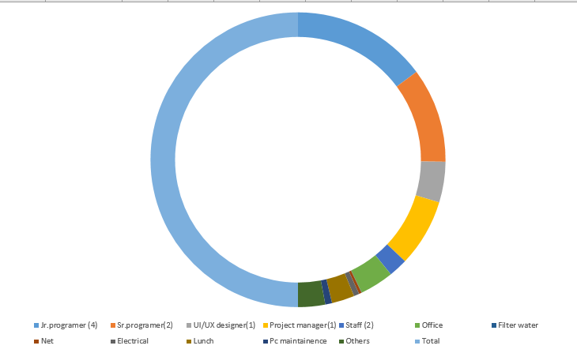

Fig: Cost analysis diagram.